Assignment-3

#### Financial Analytics

#### TITLE : Analyzing competitive advantage in real companies

**CONTENT**

#### Introduction

#### Background

#### Competitive advantage

#### Financial performance evaluation

#### Comparative analysis

#### Assessment of sustainability

#### Conclusion

In this task I am analysing the competitive advantage of two real companies operating in different industries. One company from technology sector i.e. SAMSUNG and another from the consumer goods sector ie.. INDIAN TOBACCO COMPANY LIMITED-ITC

INTRODUCTION

* **COMPANY FROM TECHNOLOGY SECTOR :SAMSUNG INC**

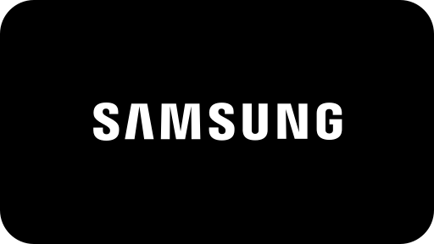

**SAMSUNG**

is a South Korean [multinational](https://en.wikipedia.org/wiki/Multinational_corporation) manufacturing [conglomerate](https://en.wikipedia.org/wiki/Conglomerate_(company)) headquartered in Samsung Digital City, [Suwon](https://en.wikipedia.org/wiki/Suwon), South Korea. It comprises numerous affiliated businesses, most of them united under the Samsung brand, and is the largest South Korean [chaebol](https://en.wikipedia.org/wiki/Chaebol) (business conglomerate). As of 2020, Samsung has the eighth-highest global [brand value](https://en.wikipedia.org/wiki/Brand_valuation).

Samsung was founded by [Lee Byung-chul](https://en.wikipedia.org/wiki/Lee_Byung-chul) in 1938 as a [trading company](https://en.wikipedia.org/wiki/Trading_company). Over the next three decades, the group diversified into areas including food processing, textiles, insurance, securities, and retail. Samsung entered the [electronics industry](https://en.wikipedia.org/wiki/Electronics_industry) in the late 1960s and the construction and shipbuilding industries in the mid-1970s; these areas would drive its subsequent growth. Following Lee's death in 1987, Samsung was separated into five business groups – Samsung Group, [Shinsegae](https://en.wikipedia.org/wiki/Shinsegae) Group, [CJ Group](https://en.wikipedia.org/wiki/CJ_Group) and [Hansol](https://en.wikipedia.org/wiki/Hansol) Group, and [JoongAng](https://en.wikipedia.org/wiki/JoongAng_Ilbo) Group.

* **COMPANY FROM CONSUMER GOODS SECTOR** :**NESTLE**

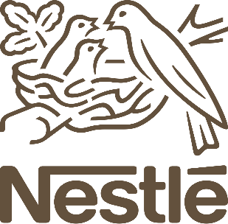

# Nestléis a Swiss multinational food and drink processing conglomerate corporation headquartered in Vevey, Switzerland. It has been the largest publicly held food company in the world, measured by revenue and other metrics, since 2014.It ranked No. 64 on the *Fortune* Global 500 in 2017. In 2023, the company was ranked 50th in the Forbes Global 2000.

# Nestlé's products include baby food (some including human milk oligosaccharides), medical food, bottled water, breakfast cereals, coffee and tea, confectionery, dairy products, ice cream, frozen food, pet foods, and snacks. Twenty-nine of Nestlé's brands have annual sales of over 1 billion CHF (about US$1.1 billion), including Nespresso, Nescafé, Kit Kat, Smarties, Nesquik, Stouffer's, Vittel, and Maggi. Nestlé has 447 factories, operates in 189 countries, and employs around 339,000 people. It is one of the main shareholders of L'Oreal, the world's largest cosmetics company.

# Nestlé was formed in 1905 by the merger of the "Anglo-Swiss Milk Company", which was established in 1866 by brothers George and Charles Page, and "Farine Lactée Henri Nestlé" founded in 1867 by Henri Nestlé.

BACKGROUND

COMPANY NAME:SAMSUNG

In 1938, during [Japanese-ruled Korea](https://en.wikipedia.org/wiki/Korea_under_Japanese_rule), [Lee Byung-chul](https://en.wikipedia.org/wiki/Lee_Byung-chul) (1910–1987) of a large landowning family in the [Uiryeong](https://en.wikipedia.org/wiki/Uiryeong_County) county moved to nearby [Daegu](https://en.wikipedia.org/wiki/Daegu) city and founded Mitsuboshi Trading Company(Kabushiki gaisha Mitsuboshi Shōkai)), or Samsung Sanghoe  Samsung started out as a small trading company with forty employees located in Su-dong (now Ingyo-dong). It dealt in dried-fish,[[16]](https://en.wikipedia.org/wiki/Samsung#cite_note-Samsung-16) locally-grown groceries and noodles. The company prospered and Lee moved its head office to Seoul in 1947. When the [Korean War](https://en.wikipedia.org/wiki/Korean_War) broke out, he was forced to leave Seoul. He started a [sugar refinery](https://en.wikipedia.org/wiki/Sugar_refinery) in [Busan](https://en.wikipedia.org/wiki/Busan) named [CheilJedang](https://en.wikipedia.org/wiki/CJ_Group). In 1954, Lee founded [CheilMojik](https://en.wikipedia.org/wiki/Cheil_Industries) and built the plant in Chimsan-dong, [Daegu](https://en.wikipedia.org/wiki/Daegu). It was the largest woollen mill ever in the country.

Samsung diversified into many different areas. Lee sought to establish Samsung as a leader in a wide range of industries. Samsung moved into lines of business such as insurance, securities, and retail.

In 1947, Cho Hong-jai, the Hyosung group's founder, jointly invested in a new company called Samsung Mulsan Gongsa, or the Samsung Trading Corporation, with the Samsung's founder Lee Byung-chul. The trading firm grew to become the present-day [Samsung C&T Corporation](https://en.wikipedia.org/wiki/Samsung_C%26T_Corporation). After a few years, Cho and Lee separated due to differences in management style. Cho wanted a 30 equity share. Samsung Group was separated into Samsung Group and [Hyosung](https://en.wikipedia.org/wiki/Hyosung) Group, [Hankook Tire](https://en.wikipedia.org/wiki/Hankook_Tire) and other businesses.

In the late 1960s, Samsung Group entered the electronics industry. It formed several electronics-related divisions, such as Samsung Electronics Devices, Samsung Electro-Mechanics, Samsung Corning and Samsung Semiconductor & Telecommunications, and opened the facility in [Suwon](https://en.wikipedia.org/wiki/Suwon). Its first product was a black-and-white television set.[[19]](https://en.wikipedia.org/wiki/Samsung#cite_note-19)

1. **COMPANY NAME : NESTLE**

Nestle is the largest food company in the world, in terms of revenue. It is a Swiss Company established in 1866 by its founder Henri Nestle. While its main foray is foods and drinks, it has hundreds of products, nearly 2000. Some of its most famous products and brands include Maggi, Kit Kat, Nespresso, Nescafe, etc.

The overall turnover for Nestle was approx 90 billion Swiss Franc in 2016. It operates 418 factories in 86 countries, employing nearly 339,000 people worldwide. Its products are available in 191 countries of the world.Nestle also is a leading researcher in the field of nutritional sciences. It invests nearly 1.5 billion Francs yearly on research and development.

* **Competitive advantages**

comparing competitive advantages of both the companies.

|  |  |  |
| --- | --- | --- |
| **Company name** | **SAMSUNG** | **NESTLE** |
| **Brand reputation** | It's essential to note that brand reputation can be subject to change based on various factors such as product performance, market competition, and public perception. Therefore, ongoing efforts to maintain product quality, innovation, and customer satisfaction are crucial for Samsung to sustain its brand reputation over time.  Top of Form | Top of Form  In its 2023 food and beverage report, Brand Finance values Nestlé brand at $20.8 billion, up from $19.4 billion, twice that of runner up, the Chinese dairy brand Yili at $10.6 billion.Snack brand Lay's has increased in value to $8.6 billion from $6.6 billion – showing that many big food and beverage companies are getting bigger in the post-pandemic economy.  Hershey, the chocolate company is ranked as the world’s “strongest” food brand, according to Brand Finance.  The fastest growing food brand is Belvita, a breakfast biscuit first introduced in France in 1998, which grew its value by more than 60% since last year |
| **Product differentiation** | Samsung employs various strategies for product differentiation across its diverse product portfolio. Here are some key ways in which Samsung differentiates its products:  Samsung employs various strategies for product differentiation across its diverse product portfolio. Here are some key ways in which Samsung differentiates its products: | Nestle brings a lot of product for target customers. Theyprovide 25 types of minerals in Nido for children. It also provides Cerelac andLactogen1 &3 for newly born baby exclusively. Now the doctors prescribe theseproducts for babies to their parents for high nutrition Nescafe is a product which contains 4 types of categories. They offer Nescafe ice for hot weather, classic for all 3 in 1 for those who are busy. They provide Maggi including Maggi instant; Maggi 2 minutes which contain various minerals, vitamins and nutrition. |
| **Technological innovation** | Samsung is actively involved in the development and deployment of 5G technology. The company manufactures 5G smartphones, network infrastructure equipment, and semiconductor chips to support the global rollout of 5G networks, enabling faster data speeds, lower latency, and new use cases for mobile communications. | Nestle’s budget friendly innovaton strategy: ‘we are faster now than many of the startups” nestle launched and tested 12% more innovations in 2021 vs 2020, most of which offered meaningful differentiation in the market place, they claimed that, “they still have 30% of their growth coming from products they launched in the last three years. Other AI and data processing tools developed by nestle focused  on mining clinical data for new discoveries such as, 1) increasing innovation without increasing the R&D budget,2) focus on high growth categories increase innovation efficiencies and also partnerships for ongoing growth.  . |
| **Market leadership** | 1. Samsung is one of the world's largest smartphone manufacturers and holds a significant share of the global smartphone market. The company's flagship Galaxy S and Note series, as well as its mid-range and budget-friendly offerings, contribute to its market leadership. Samsung's extensive distribution network, strong brand presence, and innovative product features help it maintain its position as a market leader in the smartphone industry. | Milk products and nutrition segment remains the largest contributor (40.4 per cent) to Nestle India’s sales and grew by 9.5 per cent y-o-y in 2022. Contribution of prepared dishes and cooking aids segment, led by brand Maggi, was pegged at 32.2 per cent and clocking a growth of 15.6 per cent y-o-y in 2022. “Maggi Noodles in 2022 saw the highest ever distribution and maintained market leadership as per Nielsen report,” the company added. |
| **Distribution network** | Samsung operates a network of distribution centers and warehouses strategically located across different regions. These facilities facilitate the efficient storage, handling, and distribution of Samsung products to retailers and customers, ensuring timely delivery and optimal inventory management | Milk products and nutrition segment remains the largest contributor (40.4 per cent) to Nestle India’s sales and grew by 9.5 per cent y-o-y in 2022. Contribution of prepared dishes and cooking aids segment, led by brand Maggi, was pegged at 32.2 per cent and clocking a growth of 15.6 per cent y-o-y in 2022. “Maggi Noodles in 2022 saw the highest ever distribution and maintained market leadership as per Nielsen report,” the company added.  .  Top of Form |

* Analysing financial performance
* **Analysing financial performance of**

**Technology company : SAMSUNG**

1. Revenue growth: Samsung today announced financial results for its fiscal 2024 first quarter ended December 30, 2023. The Company posted quarterly revenue of $119.6 billion, up 2 percent year over year, and quarterly earnings per diluted share of $2.18, up 16 percent year over year.

For the first quarter of their 2024 fiscal year, Apple reported a revenue of 119.6 billion U.S. dollars.

1. **Profit margins:**

Profit margin can be defined as the percentage of revenue that a company retains as income after the deduction of expenses. Apple net profit margin as of December 31, 2023 is 26.16%.

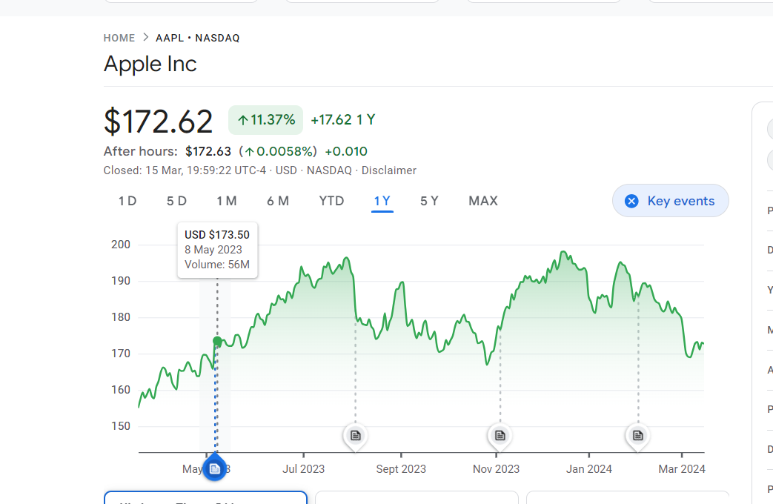

1. **Return on investment:**

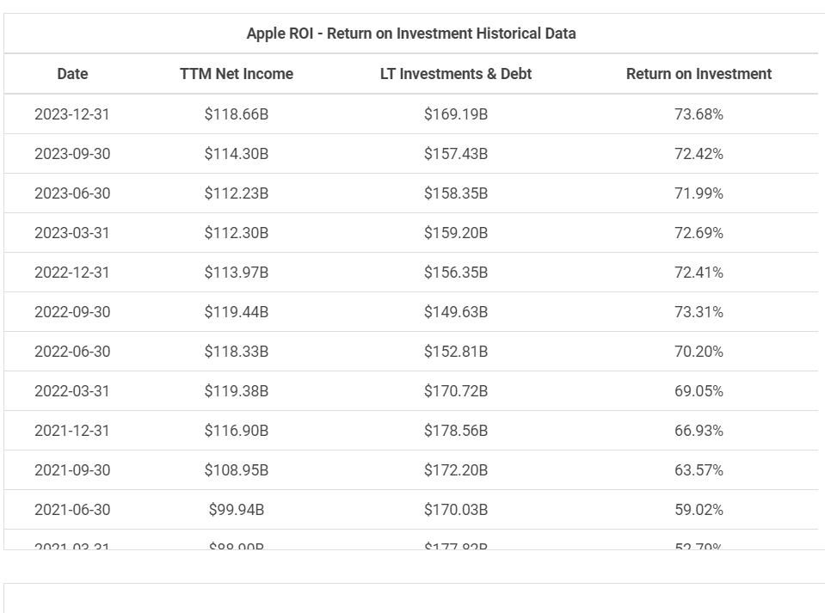

1. **Market share :**

### Market share of Samsung smartphone sales worldwide 2007-2023. Apple claimed a 24.7 percent share of the market in the fourth quarter of 2023, an increase from the previous quarter. samsung long time competitor, apple, ranked first with a market share of 16.3 percent.

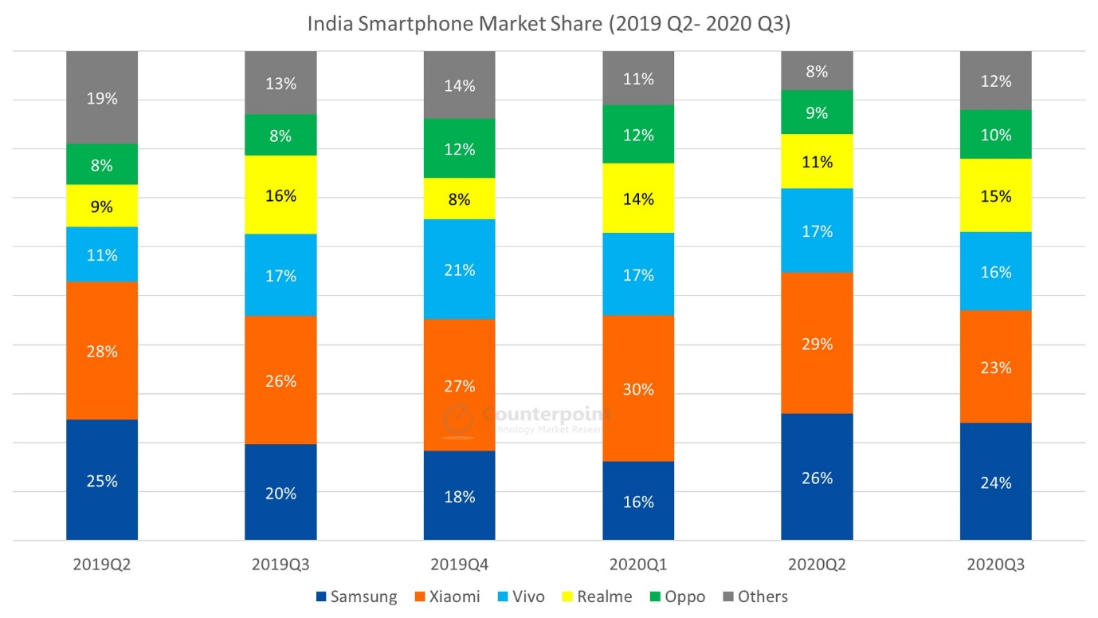

* **Analysing financial performance of**

**Consumer goods service company : NESTLE**

1. **Revenue growth:**

### Organic growth reached 7.2%, with pricing of 7.5% and real internal growth (RIG) of -0.3%. Growth was broad-based across geographies and categories. Total reported sales were CHF 93.0 billion, a decrease of 1.5% (FY-2022: CHF 94.4 billion).

### The underlying trading operating profit (UTOP) margin was 17.3%, increasing by 20 basis points on a reported basis and by 40 basis points in constant currency. The trading operating profit (TOP) margin was 15.6%, increasing by 160 basis points.

1. **Profit margin:**

FMCG major Nestle India on Wednesday reported a net profit of Rs 656 crore for the quarter ended December 2023, which is up 4% year-on-year (YoY) from Rs 628 crore posted in the same quarter last year. Revenue from operations rose 8% YoY to Rs 4,584 crore in the reporting fourth quarter.

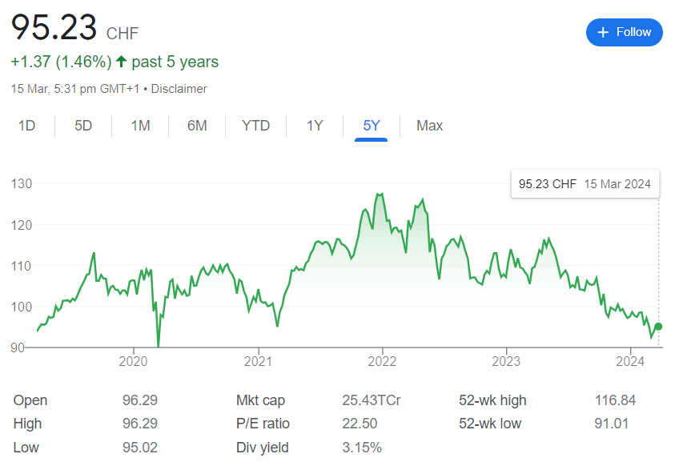

1. **Return on investment:**

Nestle SA DRC's return on invested capital hit its 5-year low in December 2021 of 12.8%. Nestle SA DRC's return on invested capital decreased in 2020 (13.2%, -3.8%) and 2021 (12.8%, -3.2%) and increased in 2019 (13.8%, +4.7%), 2022 (13.0%, +1.2%), and 2023 (13.6%, +4.8%).

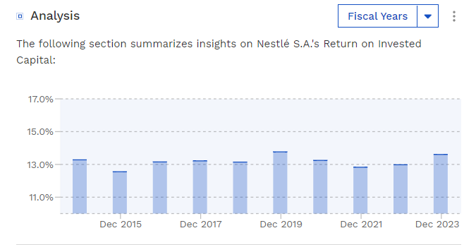

1. **Market share:**

As of March 2024 Nestlé has a market cap of $282.42 Billion. This makes Nestlé the world's 37th most valuable company by market cap according to our data.

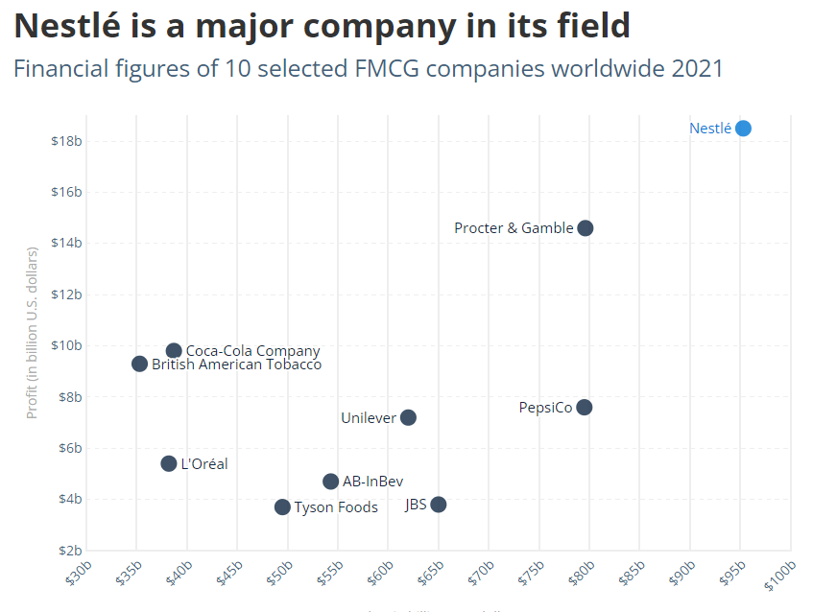

**ASSESSMENT OF SUSTAINABILITY**

#### COMPANY NAME :SAMSUNG

#### Samsung Electronics Co., Ltd. reported earnings results for the fourth quarter and full year ended December 31, 2023. For the fourth quarter, the company reported sales was KRW 67,780,000 million compared to KRW 70,460,000 million a year ago. Net income was KRW 6,020,000 million compared to KRW 23,500,000 million a year ago. Basic earnings per share from continuing operations was KRW 887 compared to KRW 3,460 a year ago.For the full year, sales was KRW 258,940,000 million compared to KRW 302,230,000 million a year ago. Net income was KRW million a year ago. Basic earnings per share from continuing operations was KRW 2,131 compared to KRW 8,057 a year ago.

**COMPANY NAME :NESTLE**

“We believe in the power of food to enhance quality of life.”

This belief fuels our desire to use our global scale, resources and expertise to contribute to a healthier future for people and the planet.

Creating Shared Value (CSV) is at the heart of our purpose: to unlock the power of food to enhance quality of life for everyone, today and for generations to come.

Our approach to sustainability is wide-ranging, underpinned by commitments to strive for net zero emissions and deforestation-free supply chains and to advance regenerative agriculture at scale. We are also committed to improving water stewardship, developing better packaging to improve their end of life options, creating opportunities for young people and building a diverse and inclusive workforce.

Packaging helps to protect food and beverages, ensure product quality and freshness, communicate nutritional information and prevent food waste.

We aim to reduce our carbon footprint and achieve net zero by 2050 at the latest.

We take a holistic approach to managing our impact on the environment – joining the dots between climate change and related issues including water stewardship, biodiversity and human rights.

The ingredients we use for our products come from nature. That’s why playing our part in taking care of the environment and supporting a just future for communities is not only critically important for people and planet, it’s a business imperative too.

#### CONCLUSION

1)Technology company : **SAMSUNG**

## Samsung is a global conglomerate that has established itself as a leader in the consumer electronics industry and beyond. The company's success can be attributed to several key factors:

## **Innovation**: Samsung is known for its relentless pursuit of innovation, constantly pushing the boundaries of technology and introducing groundbreaking products and solutions.

## **Diversified Portfolio**: With a diverse portfolio spanning smartphones, televisions, home appliances, semiconductors, and more, Samsung has built a strong presence in multiple sectors, mitigating risks and capitalizing on various market opportunities.

## **Global Presence**: Samsung's extensive global footprint and distribution network enable it to reach customers in virtually every corner of the world, establishing a strong brand presence and market share across diverse markets and regions.

## **Quality and Reliability**: Samsung products are synonymous with quality and reliability, earning the trust and loyalty of millions of consumers worldwide.

## **Commitment to Sustainability**: Samsung recognizes the importance of sustainability and has implemented initiatives to minimize its environmental impact, promote social responsibility, and uphold ethical business practices.

**2) Consumer goods sector :NESTLE**

Overall, Nestle is a highly successful and profitable company with a strong reputation for quality and innovation. The company has a wide range of well-known and popular brands and a strong presence in the global market. Despite some challenges, such as concerns about environmental sustainability and criticism of the company's marketing practices, Nestle has generally been successful in navigating these issues and maintaining its position as a leader in the food and beverage industry.

Recommendations for improvement Nestle company: One area in which Nestle could improve is in its commitment to environmental sustainability. The company has faced criticism in the past for its use of unsustainable packaging and its impact on natural resources.

To address these concerns, Nestle could invest in research and development of more sustainable packaging materials, as well as in initiatives to reduce waste and promote recycling.

Another area in which Nestle could improve is in its marketing practices, particularly with regard to the promotion of unhealthy products to children. The company has faced criticism in the past for its marketing of sugary drinks and other unhealthy products to children. To address these concerns, Nestle could adopt stricter guidelines for its marketing practices and prioritize the promotion of healthier products.

Nestle is the major player in the fast-moving consumer goods (FMCG) industry, but Nestle holds better long-term growth prospects. This is primarily due to its stronger brand portfolio, wider distribution network, and a larger presence in emerging markets.

**NAME: K.MANASA**

**COLLEGE: Dr. Lankapalli Bullayya College.**